SOBOBA SPRINGS MEN’S GOLF CLUB
“NEWSLETTER”
Newsletter Editor: Joe Kozma________June 2019______________ Volume 5 Issue 5______
To promote more interest in amature golf
TO CONFORM TO THE REQUIREMENTS OF SCGA
TO ENCOURAGE ADHERENCE TO THE RULES OF GOLFING ETIQUETTE AND SPORTSMANSHIP
TO INCREASE THE SOCIAL AND RECREATIONAL ENJOYMENT OF THE MEMBERS
This newsletter is published for the exclusive benefit of the Soboba Springs Men’s Golf Club for the express purpose of keeping members informed of club activities and for the mutual benefit of any person or persons seeking information on the activities of the Soboba Springs Men’s Golf Club.

“Membership in the Soboba Springs Men’s Golf Club has
Its privileges”

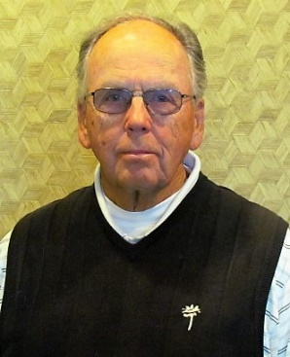
President
Bill Dahlquist

I start this article in remembrance of past member, Pete Hewitt. Pete passed away last month in Palm Desert, California. He was a long-time member of the Soboba Springs Men’s Golf Club. Pete participated in many of the club’s activities including the weekly sweeps, team play – both TVGL and SCGA, and other scheduled and unscheduled tournaments. I first met Pete when we both worked for the City of Hemet. Pete worked in the City Police Department and advanced to become the Chief of Police. Pete was great to work with and a great golf buddy to play with.

On a personal note, it’s late June and I have not been able to play since April 24th of this year due to my foot surgery. I am looking forward to getting back out on the course, however, that probably will not happen until late July according to my doctor. I thank all those that have taken time to encourage and wish me a speedy recovery.

June has been a busy month. The men’s club had several rescheduled events due to bad weather earlier in the year. One of those is the Presidents Cup. The Final match was completed on Sunday June 16th. That match was between Sean Kucera and Mark Sandoval. Mark was the eventual winner of the match that was all square through 16 holes. He birdied the last two holes to win 2 up. Mark shot 70 and Sean shot 74. I congratulate both for a great match and Mark for the Championship. The First Flight had already been decided much earlier between John Leuer and John Lange. John Lange was the winner of that match and Flight…Congratulations of both Mark and John.

Some of you may have noticed new players at some of our events. Several of these new players have come to us as a result of the closing of the Diamond Valley Golf Club on May 31st. When Diamond Valley closed, it left approximately 66 members without a home club. After discussions with Dan Long with Diamond Valley, our Treasure Dave Holmes, and Kevin O’Conner of the SCGA, we were able to transfer all the Diamond Valley members to the Soboba Springs Men’s Golf Club. Some of these “new” members have already started participating in our events. I hope we all will continue to make these golfers welcome. Through their membership, we have a better and stronger club.

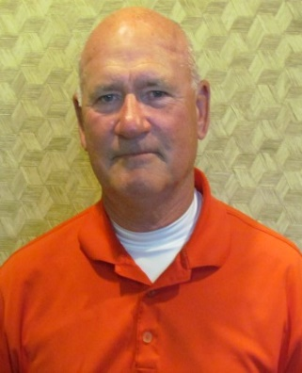
Vice President
Scott Miller
Tournament Chairman

No Article for this Month

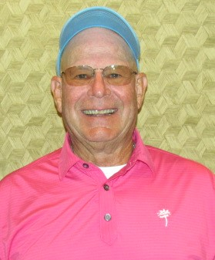
Treasurer
Dave Holmes
Rules/Handicap Chairman

The following report is submitted as of June 24th concerning the finances of our men’s club.

Current balance in our men’s club with the Bank of Hemet------------------------------------$7,745.08.
Our players fund has $1,328 so far this year. Last year around this time we hand $8,230.81 in our checking account and $1,327.00 in the players fund. We have a balance owed us by SCGA of $504.00.

This month we have 173 active members in our club. The big jump comes from the Diamond Valley Club. When Diamond Valley Golf Course closed, their members transferred to our club. A big welcome to the 66 members who transferred over. We all hope they enjoy playing the Soboba Springs Golf Course and playing in our tournaments. We also have 28 associate members.

We have just finished up two of our main tournaments for the year. The Presidents Cup Championship Flight and our First Flight Championship. At our July 13th Quarterly member meeting, tournament, and luncheon, the winners will be awarded their trophies. We will also award trophies to the winners of the Club Championship. For our new members, quarterly tournaments and meetings also include free lunch. Give it a try.
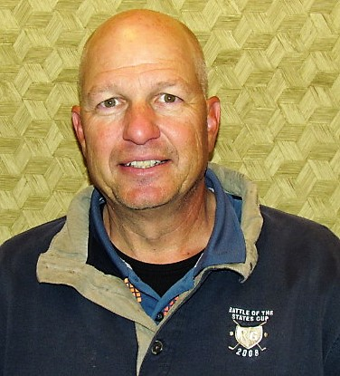
Secretary
Steve Manchester
Membership Chairman

I would like to take a moment to welcome all Diamond Valley members that have had their membership transferred to Soboba. It’s a shame that Diamond Valley closed but we are grateful to have you as members. I realize that not all of you will be able to stay as members but, we are hopeful that many of you will give us a try, play in some tournaments and join as “regulars” in our Friday and Saturday skins games or whatever other games that may be conjured up.

I hope this newsletter finds you all well. As I am writing this, the club is preparing for the Club Championship. The course is in great shape and the competition should be excellent. 2 day, 27 holes per day – got to keep your focus. I wish everyone participating the best.

We continue to grow as a club and one of our goals for the rest of this year and next is to grow our participation in tournaments. We would like to see all our tournaments have at least 32 to 40 or more participants. We are closing in on that number but, there is still much to be done. Please communicate any suggestions to Scott, Bill, Joe, Dave, or me (your current Board of Directors). We want to hear what you have to say.

Also, a shout-out to President Bill Dahlquist. His foot is healing but we miss seeing him on the course. I hope you get well soon.
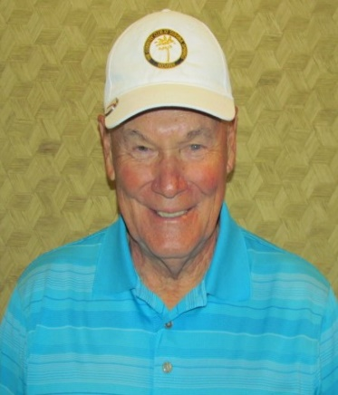
Board Member
Joe Kozma
Newsletter Editor
Webmaster
Social Media Director

Your Board of Directors work hard to promote the social and recreational enjoyment of our members. Through tournaments, quarterly meetings, luncheons, and weekly skins games, meeting and networking with the membership could not be easier. Whether you are a longtime member or just joined the Soboba Springs Men’s Golf Club, take the time to meet other club members. There’s no better place to play a round of golf than on this fabulous course we call home. The pro-shop works hard to make our day on the course enjoyable and it’s a great time to shake a new members hand, invite them for a bite to eat, or for some light refreshments. Every member is important and your Board of Directors thanks the men and women who make up our club.

Those of you who have just joined our club, the Board would like to let you know your club does have a website – lagolfclubs.com. This organization hosts our site. Once you get to the lagolfclubs.com site, click on the “our clubs” tab at the top and scroll down to Soboba Springs Men’s Golf Club. Click on our club site and you will be taken to our home page. Its best if you play around with the various contents on the site and if you have any questions please feel free to contact me at the clubs e-mail, socalssmgc@gmail.com. We also have a Facebook page – facebook.com/socalssmgc and a twitter account – twitter.com/socalssmgc. As we present trophies, have various key tournaments, or other venues of interest, I will usually put something on these sites to promote the club and our members. Should you view the website, there will be times when you will be asked for your password. REMEMBER, YOUR PASSWORD IS ALWAYS YOUR GHIN NUMBER.

On our website, you can view the latest newsletter, check the latest tournament schedule, check your handicap, join or renew your membership, plus much more. Under the players tab, you can fill in whatever information you would like on the site, buy or sell golf items, plus much more. So, take the time to browse the site and our Facebook and Twitter sites. If you have any ideas, comments or suggestions, let me know at the e-mail shown above. I am always open for improvement.

I have not gotten every new member onto our website “players” section yet, but I am working diligently to accomplish this in short order. If you cannot get into certain areas of the site, it is probably because you have not been added yet. Keep trying as I put a few on the site every day.

A Few Golf Industry Trends for 2019

Gambling on Golf – Recent legislation has opened the path for sports betting, with deals already signed in most major sports, including PGA Tour. The PGA has made it clear that golf will be no different.

Smart Technology in Golf Clubs Goes Next Level – While media companies and betting houses present data from professional players, other companies are working to gather yours. On-course data has long been the missing ingredient for club fitters and instructors because it is tough to gather, but that’s no longer the case thanks to products like Cobra Connect irons with built-in sensors from Arccos Golf, the tracking performance system.

Cobra Golf has created a first-of-its-kind and look for Arccos to expand its built-in availability in 2019. While it hasn’t been announced yet, retailers who’ve already placed orders say that Ping and TaylorMade will be the next equipment makers to do so, and they won’t be the last. Arccos said the company is rapidly expanding to the point that it predicts in 2020 more than half of all new clubs will have Arcco’s sensors as a standard feature. The sensors capture hundreds of data points throughout the round that can be used for instructions, strategizing, and more. The Arccos Caddie system uses that data in conjunction with artificial intelligence to suggest how to play each hole on any given course. The system knows your typical misses, your strengths, and more. The company says new users who log 10-plus rounds in a year showed a 3.37-stroke improvement in handicap.

Golf Retail Giant Known as Amazon- Golf retailers are starting to rebound due in part to equipment-makers cutting back on their streams of non-stop club launches. But the golf retail landscape is still shifting.

In 2018, a study of the overall effect of Amazon on the golf equipment and apparel markets, found that the golf sector is being affected much the same as other consumer products by the e-commerce giant, and especially so by Amazon Prime members. The impact is real, and it needs to be watched closely. Expect even more competition on price and additional OEM’s (Original Equipment Manufacturers) to start selling directly to consumers through their websites to cut out the middlemen.
2019 National Golf Foundation (NGF) Summary For 2018 Is Out

The NGF report looks at several areas within the golfing industry including but not limited to golf participation, engagement, rounds played, latent, demand, golf course supply and development, retail supply, golf equipment sales, and golf reach. The following are just some of the findings from 2018:

Golfs participation base remains stable, with an estimated 24.2 million people (ages 6+) who played golf on a course in 2018 – a slight increase from 23.8 million a year earlier. Almost as many people play off-course forms of the game, with 23 million hitting golf balls with clubs at golf-entertainment facilities like Topgolf, and Drive Shack, indoor simulators and driving ranges. With 9.3 million people exclusively playing golf off-course, the games overall participant pool has increased 4 percent to 33.5 million.
There were 434 million rounds of golf played in 2018, a 4.8% year-over-year decline attributable in part to the third-wettest year on record nationally, dating back to 1895, according to statistics kept by the National Oceanic and Atmospheric Association.
The total U.S. golf course supply declined by 1.2 percent, with the opening of 12.5 new 18-hole equivalent golf courses and 198.5 course closures. Closures have outweighed new openings nationwide since 2006, an ongoing correction of supply and demand within the market that followed an unsustainable 20-year building boom during which more than 4000 courses opened boosting the U.S. supple by 44 percent. Even with that trend the U.S. remains the best-supplied golf market in the world, with 14,613 facilities and 16,693 courses – more than 75 percent of which are open to all players, the highest public-to-private ration in history
Finally, some bullet points from the report:

- Golf’s total reach of about 107 million people in the U.S. is comprised of 33.5 million total golf participants, plus approximately 74 million who watched and/or read about golf but didn’t play on or off course. This represents more than one-third of the U.S. population (age 6+) and is a 10 percent increase from 2017.
- Juniors (age 6 to 17) and young adults (18 to 34) comprise approximately 35 percent of all on-course golfers, with 2.5 million junior participants and 6.1 million young adults.
- There are 5.7 million women who played golf on a course in 2018. Women account for 23 percent of the on-course golfer base and 44 percent of off-course-only play.
- Newcomers to golf are increasingly diverse: 31 percent are female, 26 percent are non-Caucasian and 62 percent are under the age of 35.
- The number of golfers age 65-and over increased almost 17 percent to 4.2 million in 2018. This number should continue to increase as the balance of the Baby Boomers cross this milestone.
- There are more than 20 million committed golfers who account for approximately 95 percent of all rounds played and spending.
- Golfers played an average of 17.9 rounds in 2018.
- The average price paid for an 18-hole round at public golf facilities is $35.

Don’t forget, the men’s club has several weekly events which members may participate in. There are skins games on Monday and Friday, ($10) buy in with one group of members (usually high handicappers) and there’s also another group of members who play on Friday and Saturday (usually low handicappers) However, all handicaps are welcome at any of the events. Take advantage of these opportunities to play a round of golf with many of our members. We would enjoy having you participate. Also, watch for the Tournament Chairman’s e-mail for any upcoming tournaments during the month.

Your Board of Directors would like to say WELCOME to all the men and women who joined our club this past year and thank you to all our members who have remained loyal to the Soboba Springs Men’s Golf Club. You are each a key component to the success of our club. Again, THANK YOU!

